

Telephone Circuits and Switches

**Report 2**

**Hardware Implementation of GPS Tracking System Using SIM808 module**

**Students Names:**

Abdelrahman Shrief - Ali Osama - Sondos Reda - Mohamed Alaa Mohamed Ramadan - Ahmed Ayman - Ahmed Tarek

**Supervisors:**

Dr. Mohamed Hamdy El-Saify

Eng. Ahmed Fathy

# Objective:

# The objective of the GPS Tracking System Via SMS Using SIM808 project is to develop a cost-effective and accessible solution for real-time tracking of objects or vehicles. By leveraging the SIM808 module's GSM capabilities, the project aims to enable remote monitoring of location via SMS, ensuring reliability and ease of use without the need for internet connectivity. The system should offer customization options, ensuring it meets specific tracking requirements while prioritizing security measures to safeguard location data and prevent unauthorized access.

# Introduction:

Real-time asset tracking and monitoring has become essential for many industries and daily life in an era where people and goods are constantly moving. Having timely access to location data has become essential for a variety of tasks, including fleet management, equipment protection, and family safety. However, conventional GPS tracking solutions might not work well in situations where internet connectivity is spotty or nonexistent. Use SMS to Access the GPS Tracking System Using the SIM808 project, a ground-breaking initiative that sought to close this gap by utilizing SMS communication enabled by the SIM808 module and the power of Global Positioning System (GPS) technology.

This project, at its core, is an example of innovation and pragmatism coming together to provide a reliable and reasonably priced remote tracking and monitoring solution. The SIM808 module functions as the central component of the system, facilitating the smooth integration of GPS positioning with GSM communication. This allows users to obtain real-time asset location updates through straightforward SMS commands.

This project is important because it is accessible and easy to use, in addition to being technically inventive. The GPS Tracking System Via SMS Using SIM808 project is made to be simple, as opposed to complicated tracking systems that call for complicated setup procedures or specialized knowledge. Users can easily interact with the tracking device with only a basic understanding of SMS messaging, making it available to a wide range of people and industries.

Furthermore, there are no limits to this system's versatility. There are many uses for this technology, ranging from fleet management and logistics optimization to personal vehicle security and other areas. The GPS Tracking System Via SMS Using SIM808 project provides a customized solution for any tracking need, be it tracking the whereabouts of valuable equipment, monitoring the movements of a delivery truck, or guaranteeing the safety of a lone traveler.

Moreover, the project prioritizes accuracy and dependability. By utilizing GPS technology's pinpoint accuracy, the system provides users with up-to-date, actionable location information in real-time. Further improving the tracking device's usefulness and efficacy are customization features like geo-fencing, regular location updates, and emergency alerts, which let users tailor the device to meet their unique needs.

The GPS Tracking System Via SMS Using SIM808 project does not cut any corners when it comes to security. To protect against unauthorized access and guarantee the integrity and confidentiality of location data, strong encryption protocols and access controls are put in place. The project gives users confidence by emphasizing security and reassuring them that their assets are safe from potential threats or breaches.

In conclusion, a paradigm shift in the field of tracking and monitoring technology can be seen in the GPS Tracking System Via SMS Using SIM808 project. It provides a flexible, affordable, and easily integrable solution for a wide range of tracking applications by fusing GPS positioning with SMS messaging. This project has the potential to completely change how we track and monitor assets in situations where internet connectivity is scarce or unpredictable because of its emphasis on simplicity, dependability, versatility, and security. The GPS Tracking System Via SMS Using SIM808 project is a shining example of innovation in an increasingly dynamic and connected world, enabling both individuals and industries to stay informed, safe, and in control.

# Circuit Diagram and software:

In next figure you can see the connection between Arduino uno and SIM808 module in the next circuit diagram .

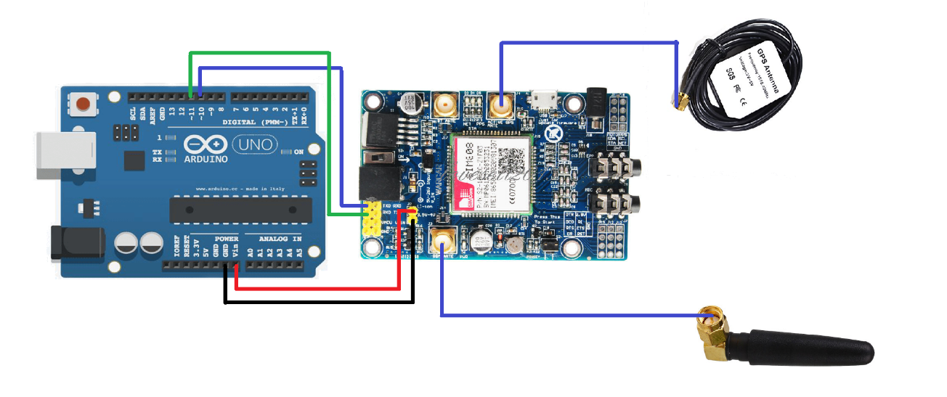

Figure 1 Crcuit Digram

**The Arduino Uno** is a popular microcontroller board based on the ATmega328P chip. It is the most widely used Arduino board due to its simplicity and versatility.

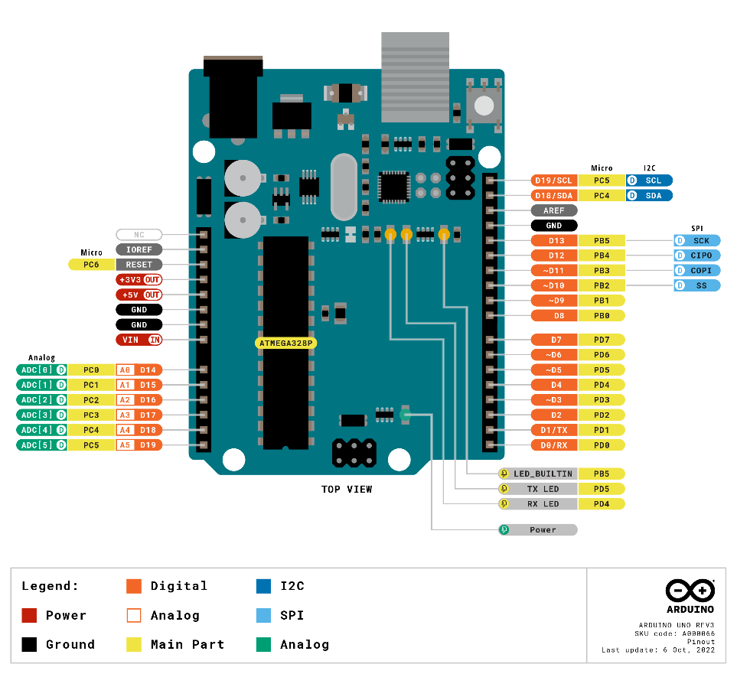

Figure 2 Arduino Uno PINOUT

Here is a concise overview:

1. **Microcontroller**: The heart of the Arduino Uno is the ATmega328P microcontroller, which runs at 16 MHz and has 32 KB of flash memory for storing code and 2 KB of RAM for data storage.
2. **Digital and Analog I/O:** The Uno features 14 digital input/output pins, of which 6 can be used as PWM (Pulse Width Modulation) outputs, and 6 analog input pins. These pins allow interfacing with various sensors, actuators, and other electronic components.
3. **USB Interface**: The Uno can be easily connected to a computer via USB, allowing for programming and serial communication. It uses a standard USB Type-B connector.
4. **Power Options**: The board can be powered via USB connection or an external power supply (7-12V DC). It also has a built-in voltage regulator, allowing it to be powered directly from a 5V source.
5. **Integrated Development Environment (IDE)**: Arduino Uno is programmed using the Arduino IDE, a user-friendly software environment that simplifies coding and uploading sketches (programs) to the board.
6. **Open-Source Platform**: Arduino Uno is part of the Arduino ecosystem, which is open-source. This means the hardware designs, software, and documentation are freely available, encouraging collaboration and innovation among the community.

Overall, the Arduino Uno is a versatile and beginner-friendly platform for electronics projects, ranging from simple blinking LED experiments to complex automation and robotics projects. Its ease of use, extensive community support, and vast array of compatible sensors and shields make it a favorite among hobbyists, educators, and professionals alike.

**The SIM808** is a versatile GSM/GPRS and GPS module that combines communication and positioning functionalities into a single compact package. Here's an explanation of the SIM808 module along with GSM and GPS antennas:

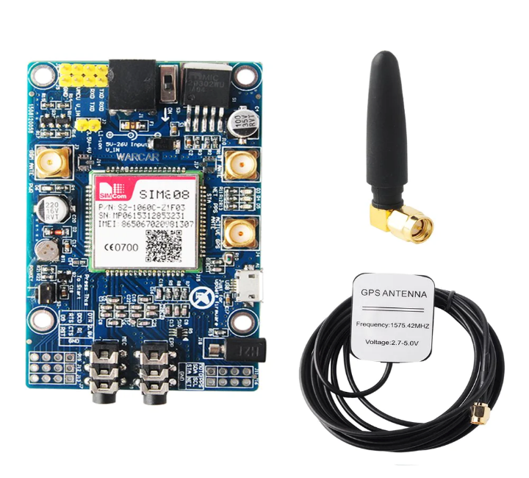

Figure 3 SIM808 Module With GPS/GSM Antenna

1. **SIM808 Module:**
   * The SIM808 module is a small electronic device that integrates GSM/GPRS (Global System for Mobile Communications/General Packet Radio Service) and GPS (Global Positioning System) functionalities into a single module.
   * It is typically used in projects requiring cellular connectivity for communication purposes (such as making calls, sending SMS, or connecting to the internet via GPRS) and GPS functionality for location tracking or navigation.
2. **GSM Antenna:**
   * The GSM antenna is used to transmit and receive GSM signals. These signals are essential for establishing communication with mobile networks, allowing the SIM808 module to make calls, send SMS messages, and connect to the internet via GPRS.
   * The GSM antenna is typically connected to the SIM808 module via an SMA or U.FL connector, depending on the module's design.
   * It's important to choose an appropriate GSM antenna with suitable gain and frequency characteristics to ensure optimal performance and reliable communication with mobile networks.
3. **GPS Antenna:**
   * The GPS antenna is used to receive signals from GPS satellites to determine the module's precise location on Earth.
   * These signals contain timing and positioning information, which the SIM808 module processes to calculate its latitude, longitude, altitude, and other location-related data.
   * The GPS antenna is also typically connected to the SIM808 module via an SMA or U.FL connector.
   * Like the GSM antenna, selecting the right GPS antenna with good sensitivity and coverage is crucial for accurate and reliable GPS positioning.

In summary, the SIM808 module, along with GSM and GPS antennas, provides a comprehensive solution for projects requiring both cellular communication capabilities and GPS-based location tracking or navigation. Together, they enable a wide range of applications, from vehicle tracking systems and asset management to IoT devices and remote monitoring solutions.

# Results and Testing:

((( ضع هنا الصور للدايرة بعد التنفيذ - صور بالكاميرا للدايرة بتاعتك - واظهر شكل المكونات كلها - ولو في داتا بتطلع على اللاب توب صورها بردوا - وحط معاها شرح اختبرت الدايرة انها شغالة ازاي وشكل الخرج كان ايه)))

# Conclusion:

هتحط هنا خلاصة الموضوع وهو انك نفذت دايرة كذا واللي هي مفيدة في كذا وكذا وانك نفذت الدايرة فعليا على بوردة بي سي بي او بوردة نحاس واختبرتها وهي شغالة فعلا. (5 او 6 جمل مثلا عن خلاصة الموضوع)

**Appendix:**

((( ضع هنا الداتا شيت بتاعة المكونات زي الايسيهات اللي في الدايرة والاردوينو لو مستخدمه هاتهم من على النت - كفاية اول صفحة او اتنين في الداتا شيت بتاعة كل مكون)))

**وفي اخر صفحة حط اسماؤكم كلكم رباعي عربي بارقام كود الطالب عشان رصد الدرجات**

**صفحة مستقلة لوحدها**